Name/ Ibrahim Usama Ibrahim Abdelhak Hegazy .

Group: One .

Section: One .

BN: 9 .

Date : 11/6/2021 .

HTML Project
Report About "Artificial Intelligence"

Application Brief:

Artificial intelligence (AI) is intelligence demonstrated by machines, unlike the natural intelligence displayed by humans and animals, which involves consciousness and emotionality. The distinction between the former and the latter categories is often revealed by the acronym chosen. 'Strong' AI is usually lapelled as artificial general intelligence (AGI) while attempts to emulate 'natural' intelligence have been called artificial biological intelligence (ABI). Leading AI textbooks define the field as the study of "intelligent agents": any device that perceives its environment and takes actions that maximize its chance of achieving its goals. Colloquially, the term "artificial intelligence" is often used to describe machines that mimic "cognitive" functions that humans associate with the human mind, such as "learning" and "problem solving"

Screen shots:

1- Mainpage

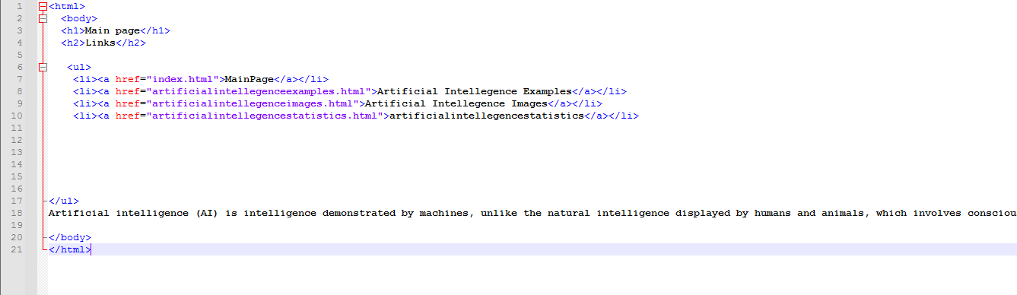
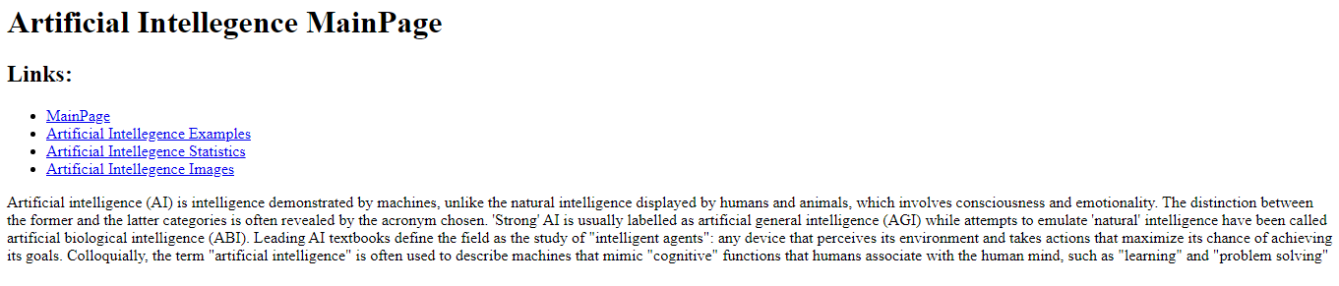
2- statistics :

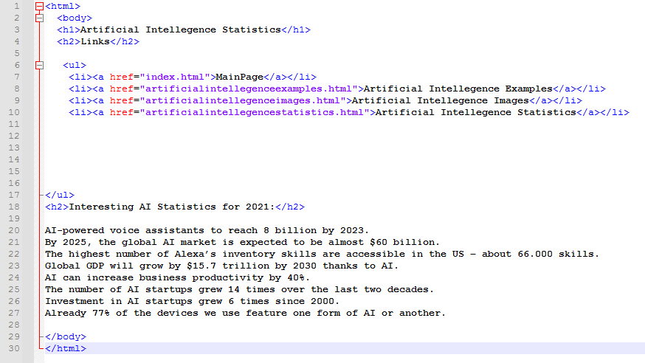

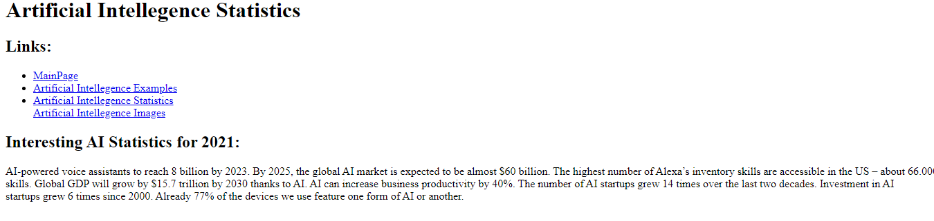

3- Images:

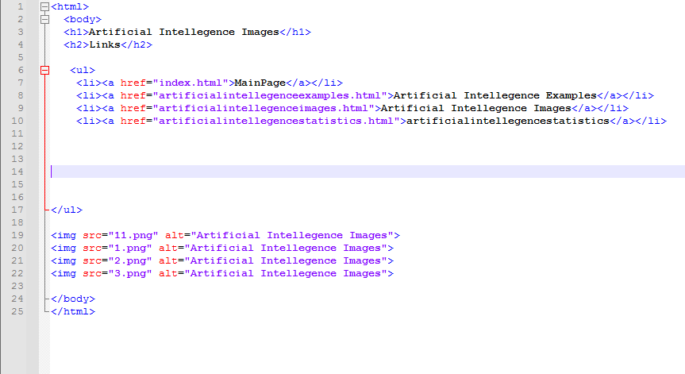

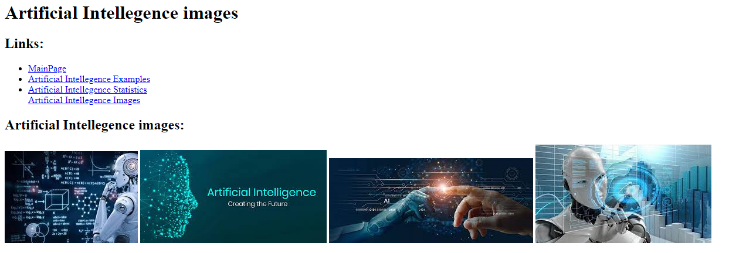

4- Examples

